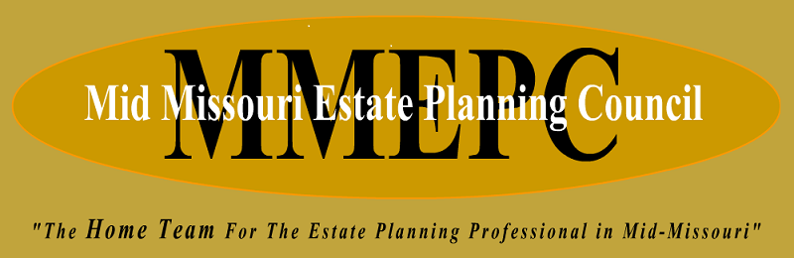

Invoice

2024 membership dues $50.00 per member

Dues can be paid by sending a check to the following:
MMEPC
PO Box 168
Columbia, MO 65205

Or we have set-up a VENMO account- @mmepc

