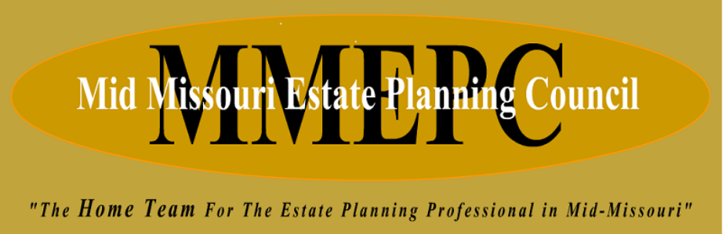

2026

Invoice

2026 Membership Dues: $50.00 per member
Dues can be paid at the next MMEPC event/luncheon:

Or we have set-up a VENMO account- @mmepc
- Please make sure to include the name(s) of who the dues are being paid for.

