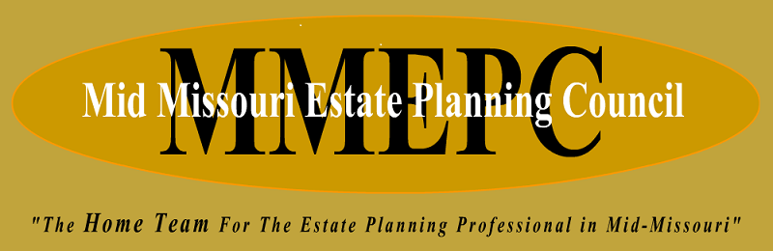

May 2025

**Invoice**

2025 Membership Dues: $50.00 per member

Dues can be paid by paying at the next MMEPC luncheon:

Or we have set-up **a VENMO account- @mmepc**

* Please make sure to include the name(s) of who the dues are being paid for.